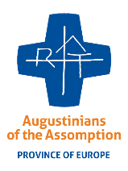**Inscription**

*English, prayer & solidarity with Assumptionists brothers*

assumptionists.london@gmail.com

**From 3 to 16 July 2023, in Bethnal Green, LONDON.**

*“English, Prayer and Solidarity Camp”, is an opportunity for young people to come together, see London in a different way, to live their Christian life through prayer, daily services with the poor and homeless people.*

1. Fist Name:………………………………………………………………….

Last Name: ………………………………………………………………...

1. Birthday: …………………/……………………/…………………………
2. Address:……………………………………………………………………

………………………………………………………………………………

1. Contact/
   * + Email: ………………………………………………………………….
     + Telephone:………………………………………………………………
2. Do you have any allergy we should know?...................................................
3. Questions/